Group Summary

Students Name
Institutional Affiliation
Course Code and Name
Instructors Name
Date
Group summary
The experimental group on my site is theater/drama actors. The actors are usually decorated to suit the play's nature or action before the audience. The group convenes in an auditorium with good artwork, as shown in figure 1.
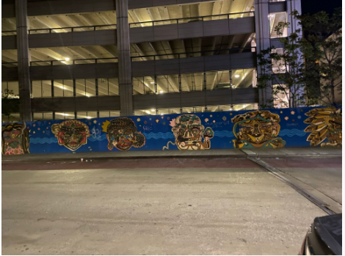
Figure 1-decorated theater(auditorium) in nearby vicinity (Source: author)
They are very cooperative as each party depends on the other to enact a good presentation attractive to their spectators and audience. The group on the site is wearing costumes that differentiate them from the rest of the people in the neighborhood. The primary purpose of the film actors is to enact plays that will entertain their audience and spectators. They usually present their sports and drama during important community days like cultural day, education day in nearby schools, public holidays, cultural weddings, and revamping their YouTube business channel. The drama team structure consists of a protagonist (main character), a narrator, antagonist, love interest (main desire object by the protagonist), confidant, and deuteragonists. The drama takes place in a live setting in the nearby estate. The group has a director who usually sets up the rules that govern the acting group and all the parties therein. However, the members unanimously agree to follow the set rules and regulations through a consensus. The attendees in the group include all the drama members who enact a play to be uploaded to their social media sites.
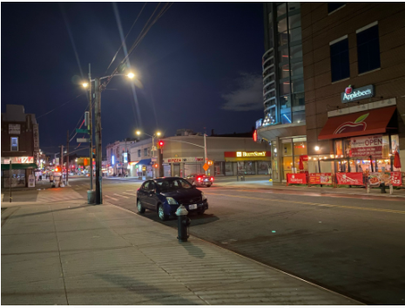
Figure 2-a drama group-member driving home after a practice session (Source: author)
The interactive styles of the drama group are unique. The interaction between the actors and non-living items in the group as they act seems natural. The people appear real even as they perform with their fellows. Again, it is essential to note that a play cannot be successful without an audience. The drama team also interacts with its audience. Through my observation, the actors, in most cases, can directly or indirectly involve the audience during their acting. This kind of actor-audience interaction makes the play interesting, captivating, and successful. Since most of the time, group presents during cultural days, they showcase a more confident demeanor but varied characters to increase their' plays authenticity and people's various behaviors, respectively.
The team has a hilarious member who acts as tension releasers. Again, other members encourage their fellows who feel discouraged, thus playing social-emotional roles. Regarding task roles, the drama team has information gatherers who collect suggestions from members about areas of improvement. Some cheerleaders encourage the team to perform better. The group's communication follows the horizontal, bottom-up, and downward trends. Unexpected ordeals precede their appearances in the observed show, and this has been the group's trend.
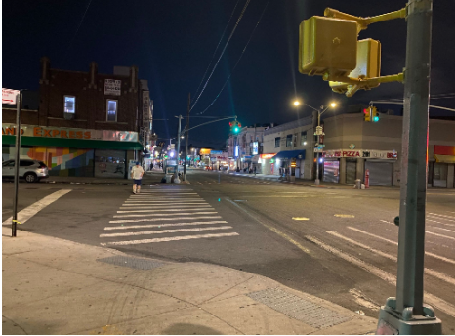
Figure 3: drama team member walking home at night after practice (source: author)
The leader seems to be firmer in instilling the group's behavior while on and off the stage. Since they are passing important information to society about a certain issue, they are to remain true to the socially acceptable behaviors. The drama team director is the main decision-maker and counselor who resolves conflicts in the group when actors disagree on natural terms outside acting. All the group's members are friends and spend their time together in solace and laughter even after completing their acting. They are so attentive to their director, who is the group's main leader. Although they are free with him during the training, the actors maintain professional gaps during orientation and recruitment of new group members. The actors reside in different areas within the City and drive their cars in streets heading to their homes after acting. Facial expressions are the main -emotional features used to indicate different feelings during the play. Most of the drama group members are grown-ups who have vast experience in the film industry. Their competencies have assisted them in maintaining the right attitude during work.
Group stages
The drama group on my site consists of members from different backgrounds. All groups, just like the drama team, require therapy. In my site drama group, the therapeutic process is at the working stage. This is because the members seem comfortable fulfilling the group's role of offering quality plays to the society around it. Essentially, all kinks seem to have been ironed out during the transition stage. Through observations, the drama group members seem mature and prudent in exploring their emotions and thoughts triggered by their fellows' words. The members do not seem to get offended easily. The minimal cases in which some members feel they are being criticized or judged, the director, counselor chips in to resolve the members, stalemate amicably, and use few words.

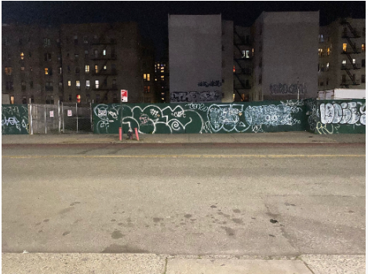
Figure 4-drama group decorated theater veranda (source: author)
Helping Skills
The drama group cannot succeed without key skills. These skills are the basis of engaging in any acting scene. The common skills observed in the drama team commonly employed in plays include gestures, eye contact, Facial expression, body language, and gait. Gait refers to an actor's walking pattern. It is usually depicted during stage movements to enhance characterization. For example, I saw one of the drama members strut and stagger to describe arrogance in a play. Body language refers to the stance and posture and can indicate an actor's personality and feelings. For example, most confident drama team actors stand straight while the naïve ones cross their arms with their heads down. Eye contact refers to the situation where two people directly look into each other's eyes. For instance, love episodes are depicted with direct eye contact, while strained associations are represented by withdrawn eye contact. Facial expressions, on the other hand, convey emotional states and are showcased by facial movements. They happen in various subtexts of happiness or anger, confusion, surprise, or sadness.
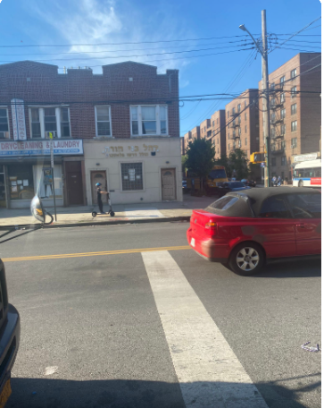
Figure 5- a car packed in a nearby street close to drama group theater(source: author)
Evaluation
The main accomplishment in the experimental group's work is finishing one of their plays by the Title' Betrayal in the City.' Some of the group's barriers and problems include limited space, costly costumes, and unpredictable weather. The language barrier has also been a challenge in the group. The team does its plays in English, but the audience includes non-English speaking members. However, with the widespread use of non-verbal cues, almost 90% of the enacted information reaches the audience. The team members interact freely and are friends implying that their cohesiveness is very high. The facilitator employs a democratic style of leadership where the opinions of the majority win. The group aspires to be the best drama team globally. Their friendly interactive nature is likely to push the groups to achieve their goals as they are more empathetic to each other's needs besides not harboring grudges.

